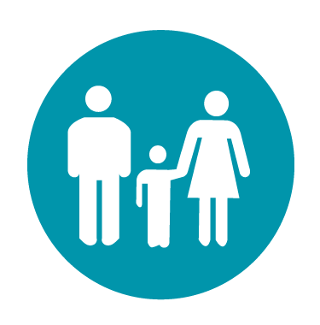
Individuals and families / whānau
Te tangata me ngā whānau

Understand your risk
Be aware of the hazards or disruptions you could experience, your exposure – the things you have that are at risk from those disruptions, and your vulnerability – how you and your things might be adversely affected.
Reduce your risk factors
Think about the range of ways you could reduce your exposure or vulnerability, and invest in doing so where possible.
Future proof where possible
When making new purchases, think about how to future-proof yourself and build in resilience.
Prepare yourself and your household
Think about the range of impacts that could occur from emergencies (for example, power, water, or communications outages, access or transport issues, the need to stay in or out of your home for an extended period). Think about the things you would want or need to have available to you during that time. Remember to include animals in your emergency preparedness.
Plan for disruption
Consider how you would meet up with family/whānau and friends if there was a communications outage or access issues.
Stay informed
Talk to others about risk and resilience; find out the different ways you can stay informed during an emergency and how to receive alerts and warnings.
Know your neighbours
Get to know your neighbours and participate in your community – you are each other’s front line.

